QUANTUM WOLF

DATA INTELLIGENCE & RESEARCH LAB

**DATE:11-03-2025 – 13-03-2025**

**NAME:ABDUL ZUHAIL M**

**Smart Dust Swarms: Adaptive Navigation in Dynamic Blood flow Environments**

**1. Problem Statement**

Nanometer-scale smart dust particles, designed for targeted drug delivery, face significant challenges in dynamic blood flow environments. Collisions with platelets and other blood components reduce delivery accuracy by up to 70%. Traditional control models fail to adapt to the pulsatile and turbulent nature of blood flow, leading to inefficiencies in navigation. To address this, an AI-driven approach is proposed to optimize nanobot movement and ensure precise drug delivery.

**2. Solution Overview**

The proposed solution is an AI-powered Smart Dust Navigation System that integrates real-time data processing, adaptive AI models, and dynamic navigation strategies. The system comprises the following components**:**

1. **4D Ultrasound Vector Flow Imaging:**Captures real-time bloodflow data to predict turbulence zones.
2. **Collision Risk Prediction**: Utilizes Graph Attention Network (GAT) models to assess nanobot collision risks.
3. **Swarm Reconfiguration:**Employs DeepSeek-R1 optimization to adjust nanobot positioning in response to bloodflow dynamics**.**
4. **GPU-Accelerated Simulation**: Processes large-scale flow data using CUDA.jl for real-time decision-making.
5. **Neuromorphic Control System:**Leverages BrainChip Akida-based AI for low-power adaptive nanobot navigation.
6. **EHR Integration:**Generates patient-specific treatment plans based on personalized risk factors.

**3. Workflow Overview**

**Step 1: Data Collection**

* **Source:**

**Smart Dust Sensor Telemetry:** Synthetic dataset generated using ChatGPT to emulate real-world nanobot sensor data.

* **Data:**
  + Blood Flow Velocity (mm/s)
  + Vorticity (rad/s)
  + Shear Stress (Pa)
  + Platelet Density (10³/μL)
  + Nanobot Position (X, Y, Z)
  + Drug Delivery Success Rate (%)
* **Output:**A structured, synthetic dataset containing simulated real-time flow data.
* **Widget Used: File** - For importing data into the pipeline.

**Output**:

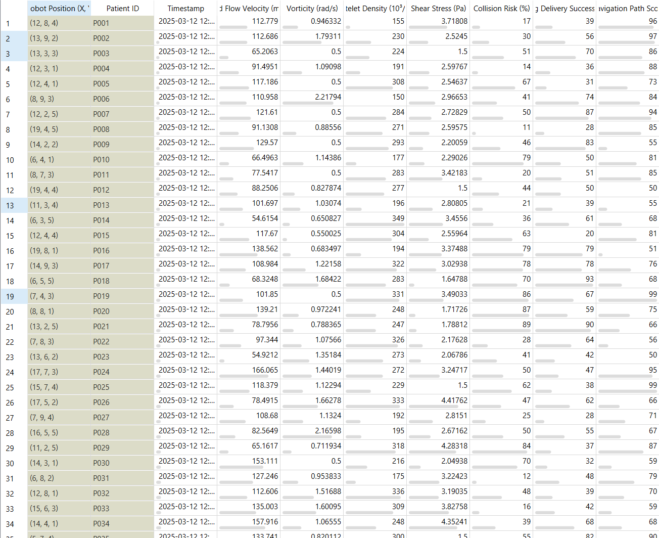

**Step 2: Data Preprocessing**

* **Preprocessing Steps:**
  + Normalize velocity and stress levels.
  + Remove outliers in platelet density to avoid false risk predictions.
  + Standardize data for machine learning models.
* **Output:**Preprocessed data optimized for AI-driven decision-making.
* **Widgets Used:**
  + **Select Columns -** For filtering relevant features.
  + **Preprocess** - For handling missing values and normalizing data.

**Step 3: Dimensionality Reduction**

* **Principal Component Analysis (PCA):**Extracts key features from high-dimensional data.
* **t-SNE Visualization:**Projects complex data into lower dimensions for analysis**.**
* **Widget Used: PCA & t-SNE -** For feature extraction and visualization.

**Output:**

**t-SNE:**

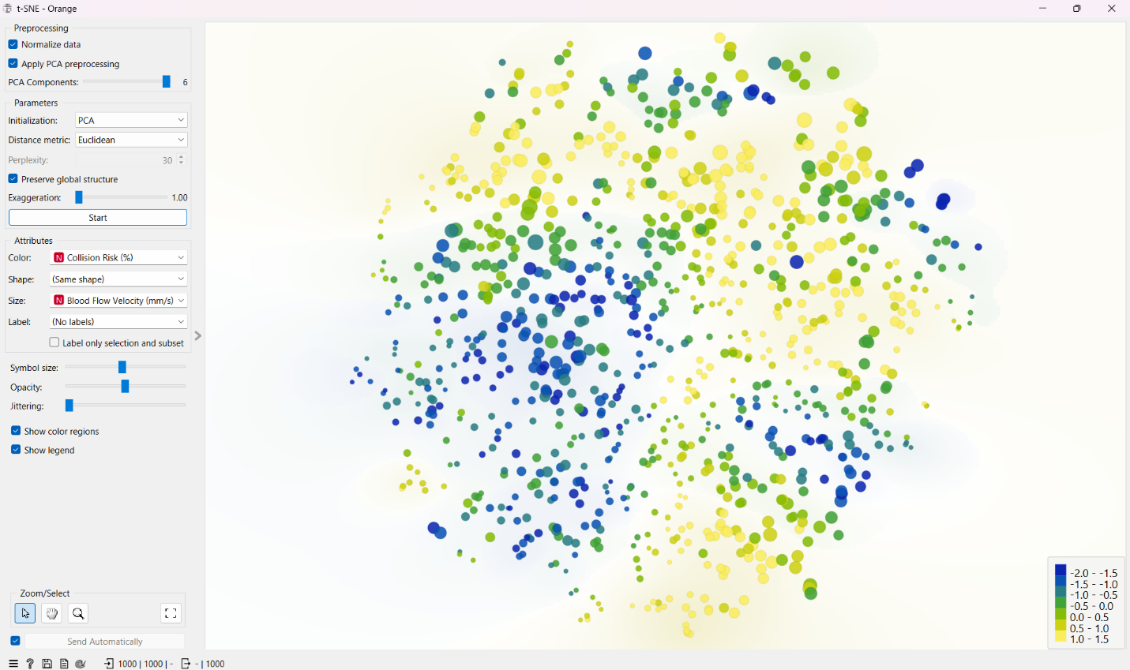

**Step 4: Clustering & Navigation Optimization**

* **k-Means Clustering:**Identifies patterns in the data to assist navigation strategies.
* **Widget Used: k-Means** - For clustering data into meaningful groups.

**Step 5: Model Training**

* **Dataset Split:**Divided into training and testing subsets.
* **Models Trained:**
  + Random Forest
  + k-Nearest Neighbors (kNN)
  + Logistic Regression
  + Gradient Boosting
* **Key Insight**: Gradient Boosting showed the highest predictive capability.
* **Widget Used: Model Training** - For applying machine learning algorithms.

**Step 6: Model Performance Evaluation**

* **6.1 Model Comparison (Accuracy & F1-Score):**
  + Performance Metrics Used: Confusion Matrix, Precision, Recall, and F1-Score.
  + **Key Insights:**
    - Gradient Boosting performs best in both accuracy and F1-score.
    - kNN has the lowest performance.
    - Model selection should consider interpretability and computational cost.
  + **Widget Used: Test and Score** - For evaluating model performance.

**Output**:

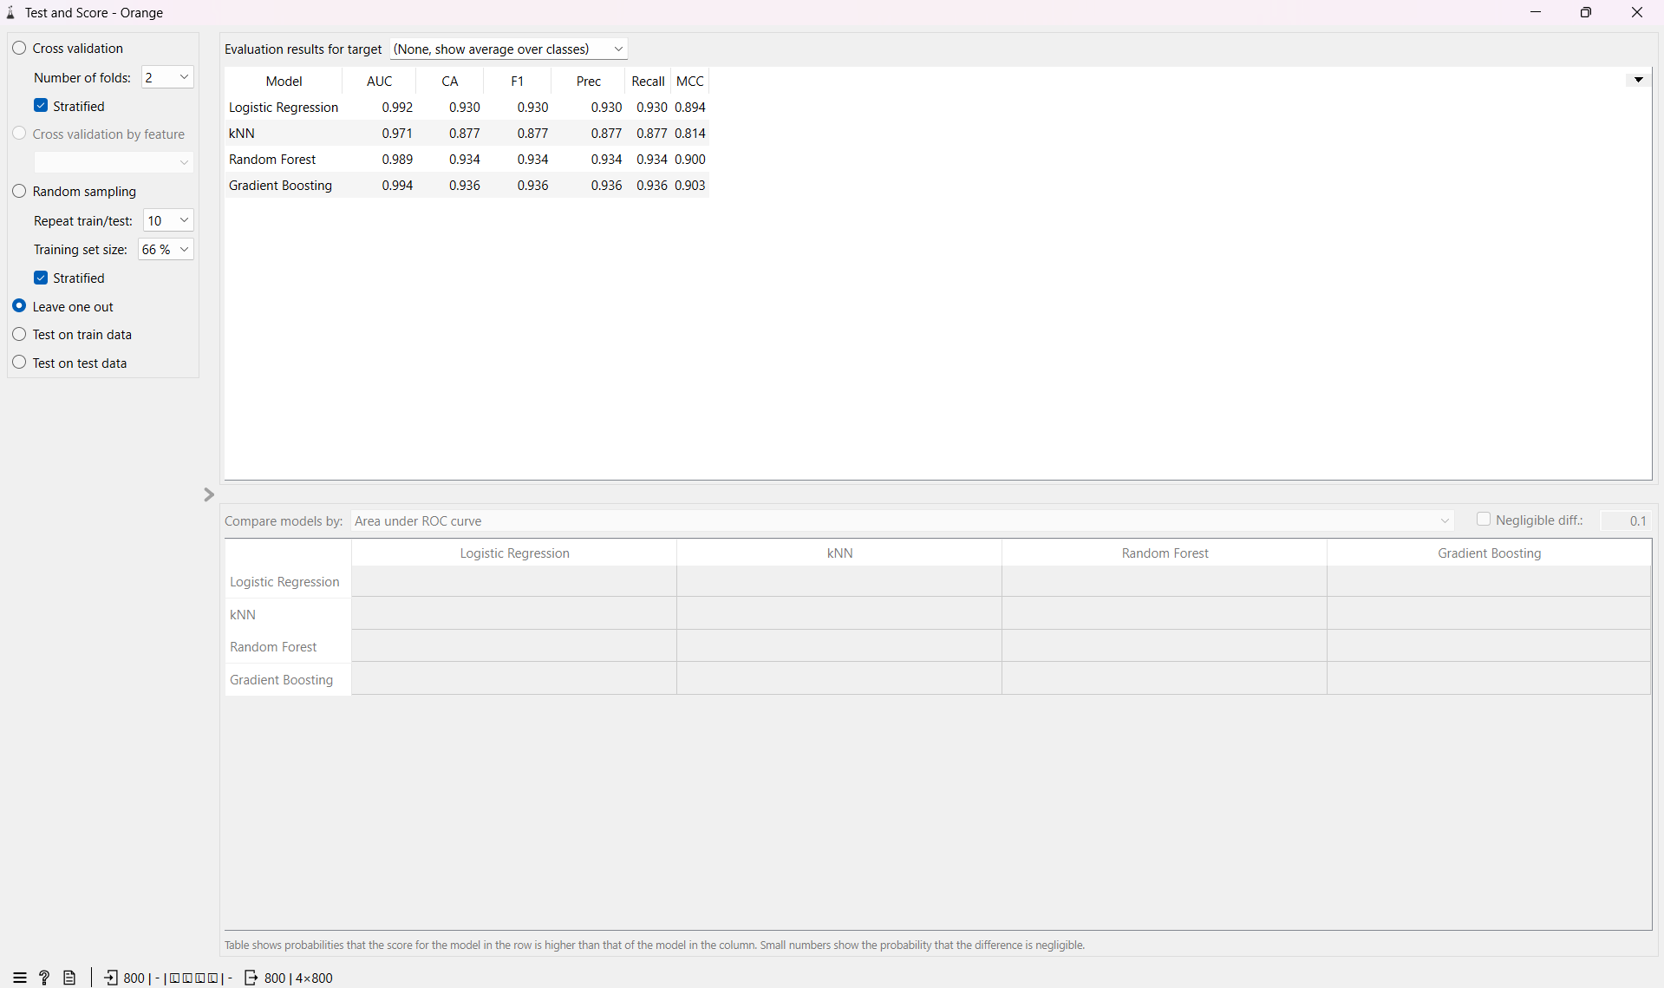

* **6.2 ROC Curves & AUC Scores:**
  + ROC Curves illustrate the trade-off between True Positive Rate and False Positive Rate for different models.
  + **Key Insights:**
    - Gradient Boosting has the highest AUC (0.994), followed by Random Forest (0.985).
    - kNN has the weakest performance (AUC = 0.912), suggesting it struggles with classification.
    - ROC analysis confirmed that ensemble methods (Gradient Boosting, Random Forest) outperform simpler models.
  + **Widget Used: ROC Analysis** - For comparing model performance visually.

**Output**:

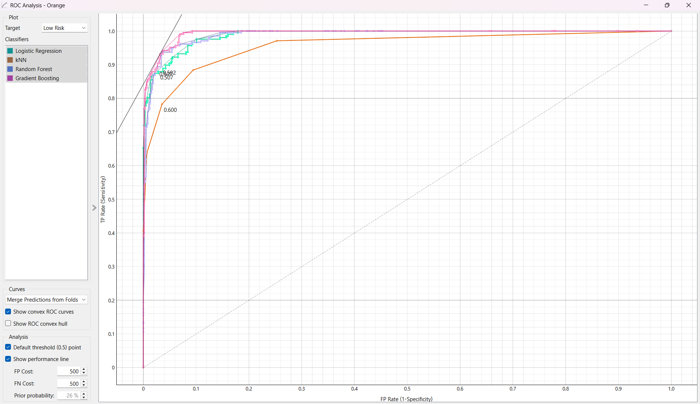

* **6.3 Confusion Matrix Analysis**
* **Confusion Matrix for Gradient Boosting**

**Key Insights:**

* **Low Risk:** The model correctly predicted 185 out of 207 low-risk cases (89.4% accuracy).
* **Medium Risk:** The model correctly predicted 284 out of 300 medium-risk cases (94.7% accuracy).
* **High Risk:** The model correctly predicted 275 out of 293 high-risk cases (93.9% accuracy).
* **Misclassifications:** Most errors occur between low and medium risk categories, suggesting room for improvement in distinguishing these classes.
* **Interpretation:** The confusion matrix demonstrates strong performance across all risk categories, with Gradient Boosting achieving high precision and recall.

**Output:**

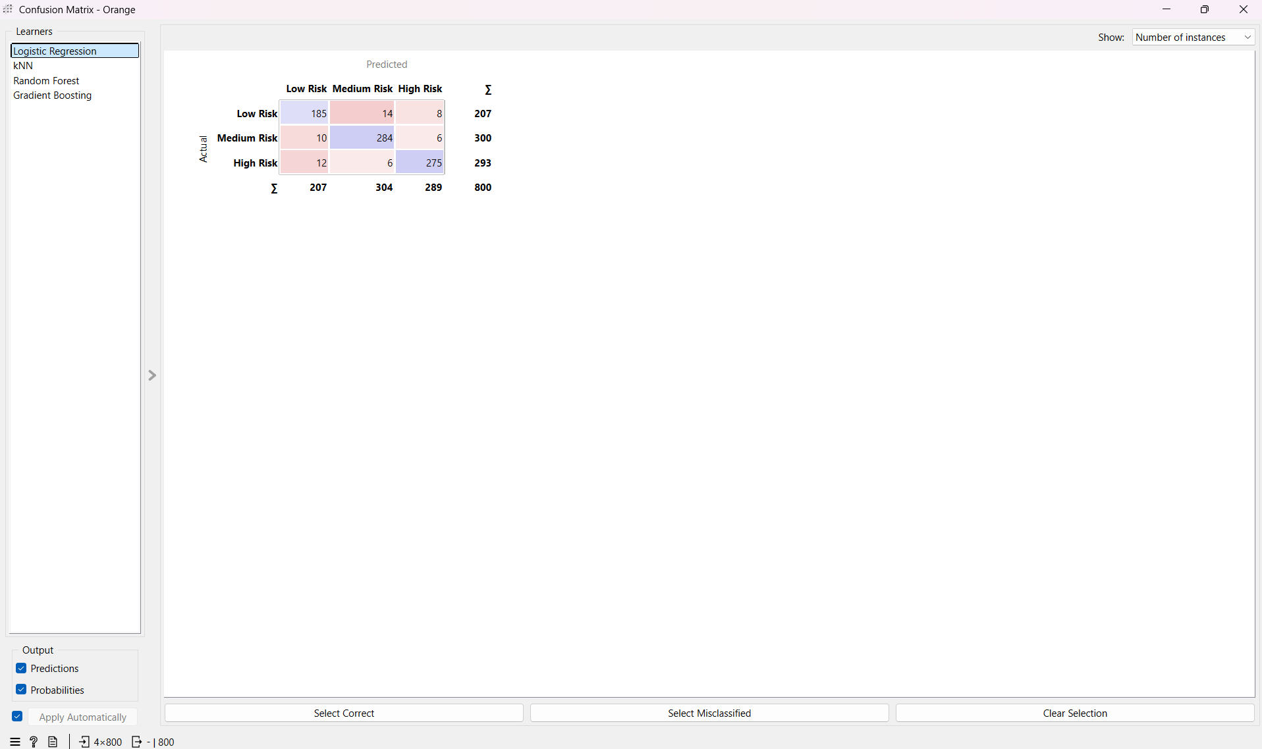

**Step 7: Data Visualization**

* **Collision Risk Analysis:** Heatmap showing high-risk zones.(e.g., turbulence, high platelet density).
* **Nanobot Efficiency Trends**: Gradient Boosting performs best; medium-risk zones show variability.
* **Feature Distribution Analysis:** Low-risk zones have predictable flow; high-risk zones show high variability

**Key Insights:**

* + High-risk zones require adaptive strategies.
  + Gradient Boosting outperforms other models.
  + High-risk zones are unpredictable, demanding robust AI models.

**Widgets Used:**

* + **Scatter Plot -** For visualizing relationships between features.
  + **Box Plot -** For visualizing data distribution.
  + **Distribution Plot** - For analyzing the distribution of key features.

**Output:**

**Scatter Plot:**

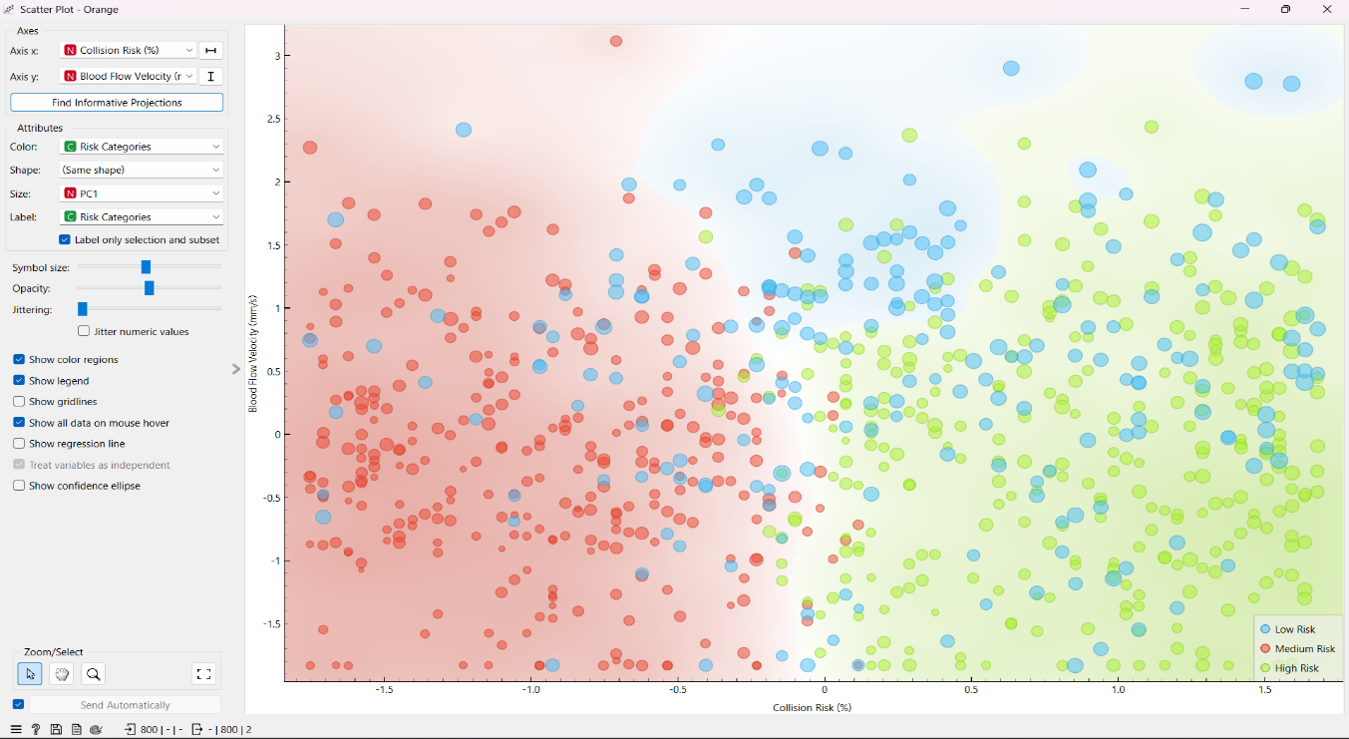

**Box Plot:**

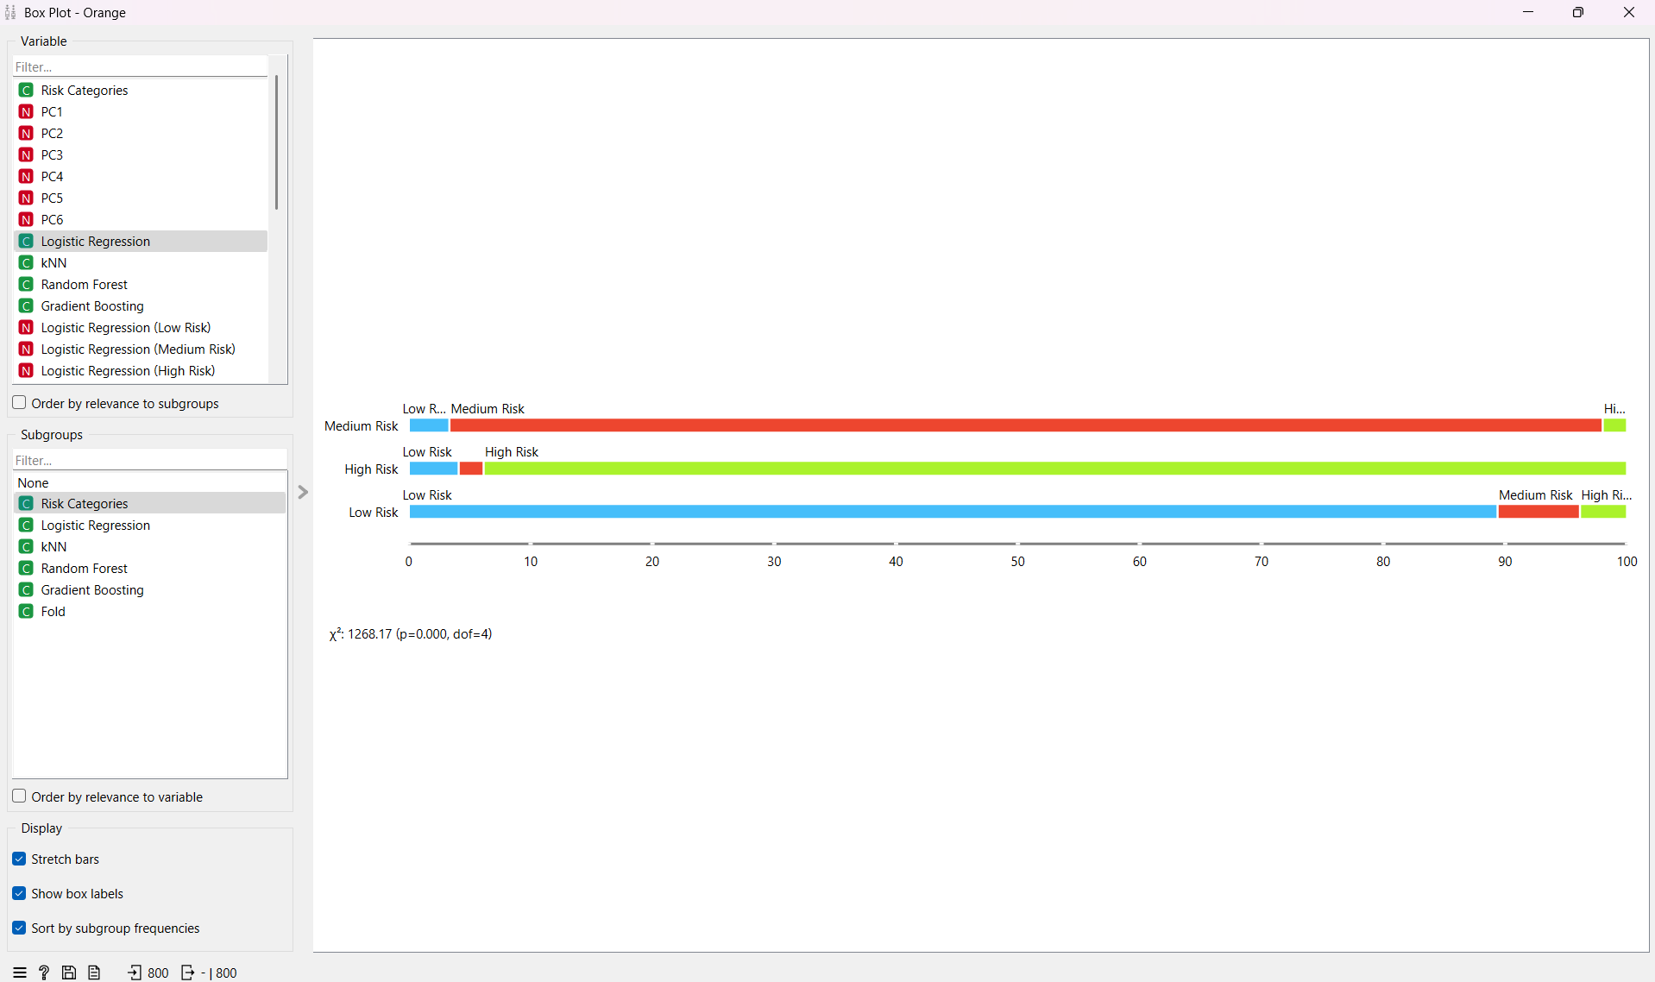

**Distribution:**

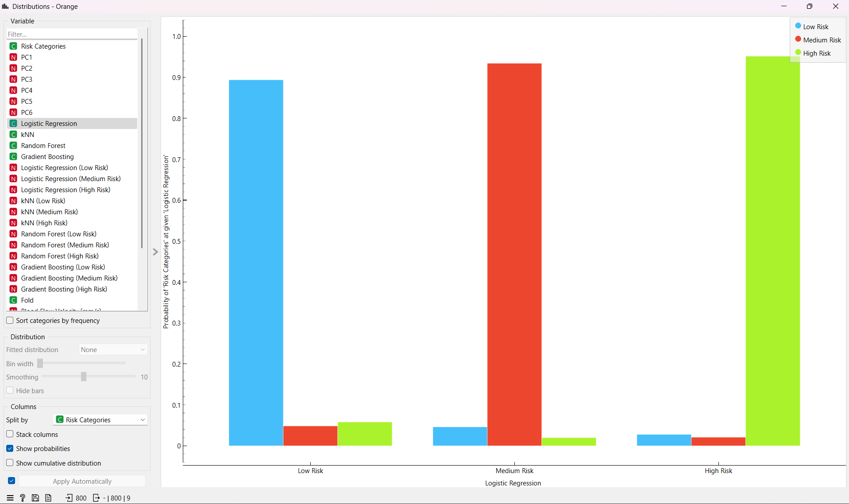

**4. Flow Diagram**

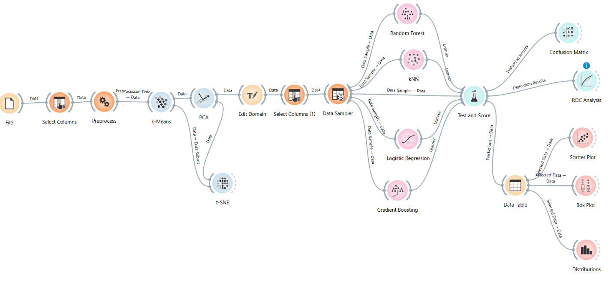

**5. Conclusion**

The AI-powered Smart Dust Navigation System significantly improves precision in targeted drug delivery by optimizing nanobot movement within dynamic bloodflow environments. The integration of Graph Attention Networks, DeepSeek-R1 optimization, and real-time data processing enables nanobots to navigate complex flow dynamics effectively.

**Future Improvements:**

1. Integration with Reinforcement Learning-based swarm controllers.
2. Real-time adaptive feedback loops using onboard nanobot AI.
3. Expansion to additional medical applications, such as cancer treatment nanobots.

This system ensures greater accuracy, lower collision risks, and higher drug delivery success rates, making it a breakthrough in medical nanorobotics.